**Dark Knight**

Dark Knight is a game where players battle enemies like Goblins and Thieves. Players can equip items dropped by defeated enemies. Your task is to implement **polymorphism**, **interface**, and **abstract class** within the application. Feel free to include any additional features that may enhance the game. Here are the game details:

* This is the minimum requirement for the class model:
  + The game consists of Entity such as Player, Goblin and Thief. Player is limited to possessing only one item.

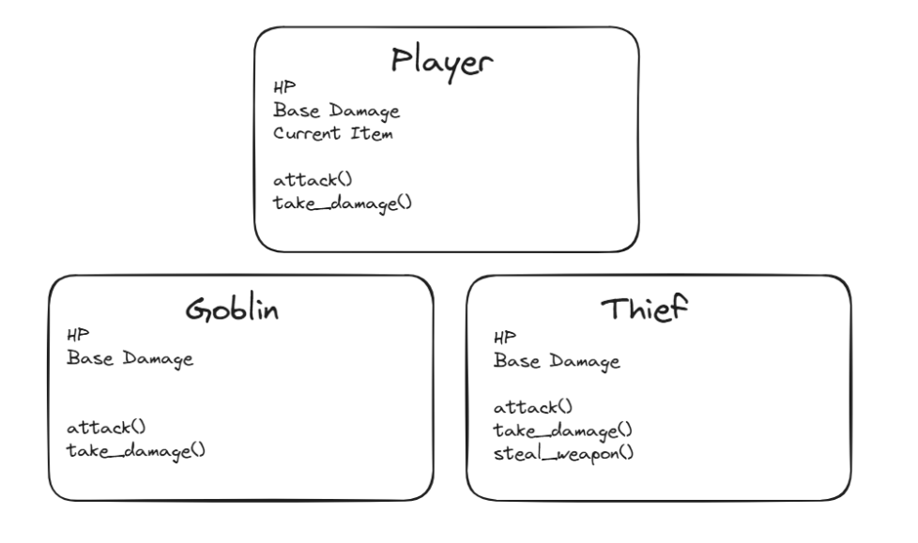

* + The items that is dropped by the enemies consists of :

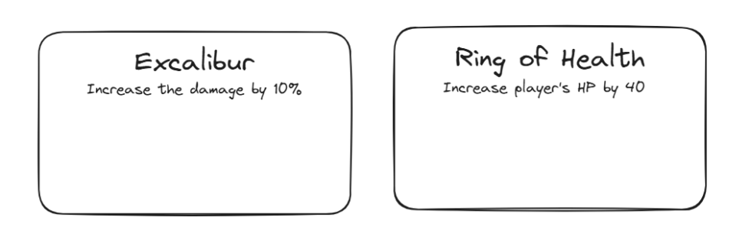

* The application consists of 2 menus

1. Play
2. Exit

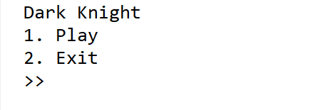

* If user choses menu **1** (“**Play**”), then the program will:
  + Ask the user to input the **user’s name**. Validate that the name must be **atleast 5** characters long.

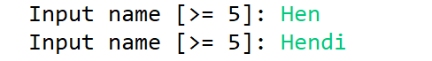

* + Greet the player.

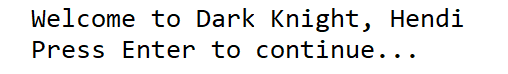

* + Randomize the enemy between Thief or Goblin. Initialize the enemy stats and player stats according to this table :

| Entity | HP | Base Attack |
| --- | --- | --- |
| Player | 100 | 20 |
| Goblin | 80 | 20 |
| Thief | 60 | 15 |

* + While the player is alive, display the player’s **HP, player’s Base Attack, and enemy’s HP**. The player and enemy will **take turns** to attack each other where the damage is **randomized** between **0 – Base Attack**. Every turn, **Thief** has a **25% chance** to **remove** the player’s item.

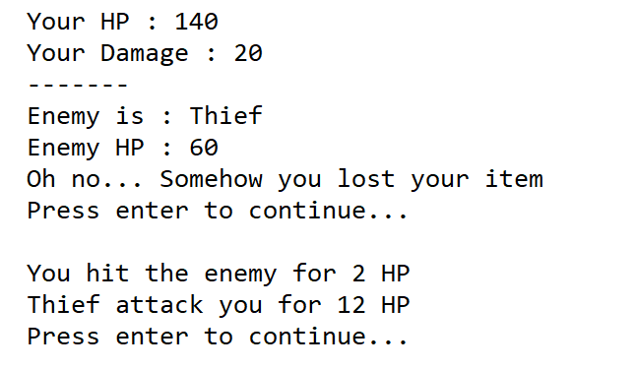

* + Every time the **enemy died**, reset the **player’s HP** and initialize a **new enemy** between **Goblin** and **Thief**. If the player **doesn’t have any item**, the player has a **25% chanc**e of obtaining a random item between **excalibur** and **ring of health**. Excalibur will **increase the player’s damage by 10%** and ring of health will **increase the player’s HP by 40**.

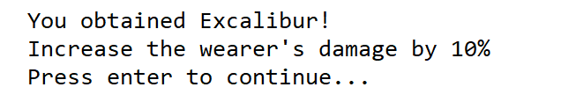

* + If the player **has no health left**, display the information and return the user back to the main menu.



* If user choses menu **2** (“**Exit**”), then the program will terminate